**Summary of the Project**

* The scope of the project is to create student i-card. He /she have to put their details on it and can create their user id. Student can add their demographic information in it.
* So automation test case is all about automating this functionalities. Idea is to create all the process into the cypress.
* It covers all the functional tests as well as give the result for that. Also it covers all the negative test cases that should not allow user to do.

**Project Planning and Management**

* It created black box testing after tested most of the functional test cases

**Project coding**

* Used cypress for the creation of the first level test case and eclipse into the tool for the coding.
* Used PHP for the coding the business logic

**Project Coding with PHP using SDLC and automation with cypress**

* Coded Project with SDLC process and followed water fall life cycle since agile is not possible with small project.
* Tested Project with the automation software and with manual test cases.
* Created all the negative test cases and executed with cypress and manually too.

**Project Add Student page Screenshot**

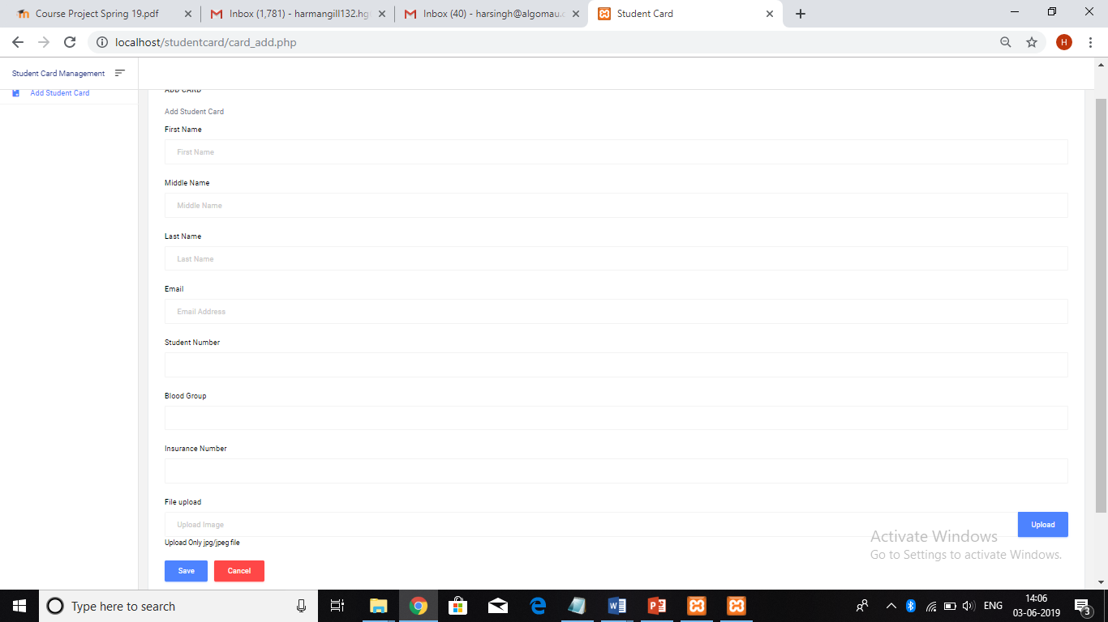

**Student List page**

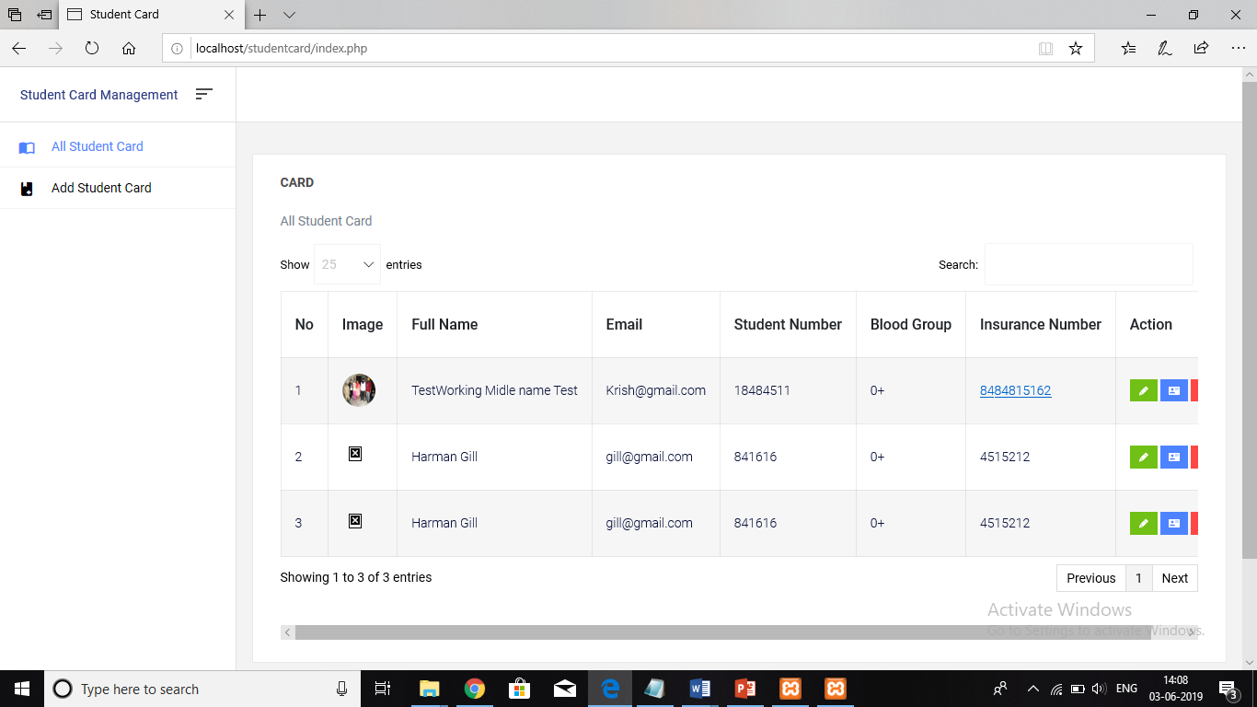

**Edit page screenshot**

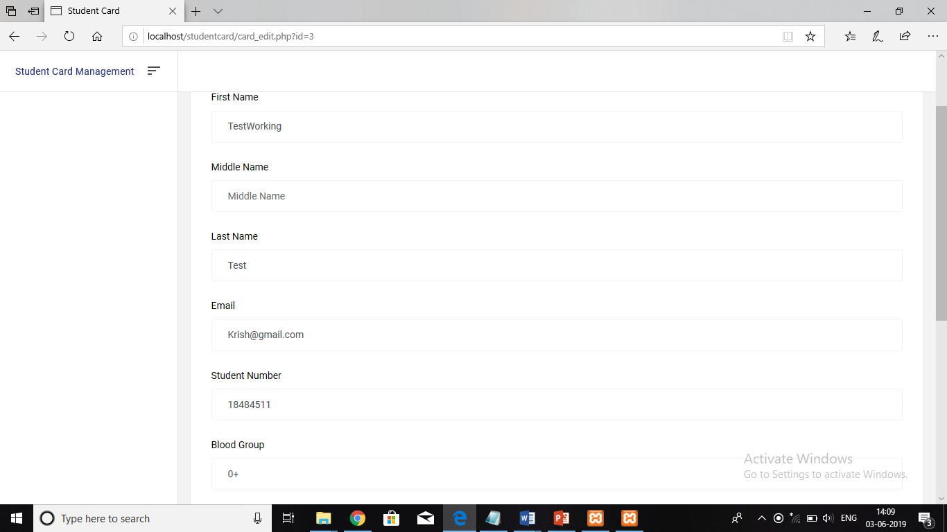

**Student card screenshot generated by Project**

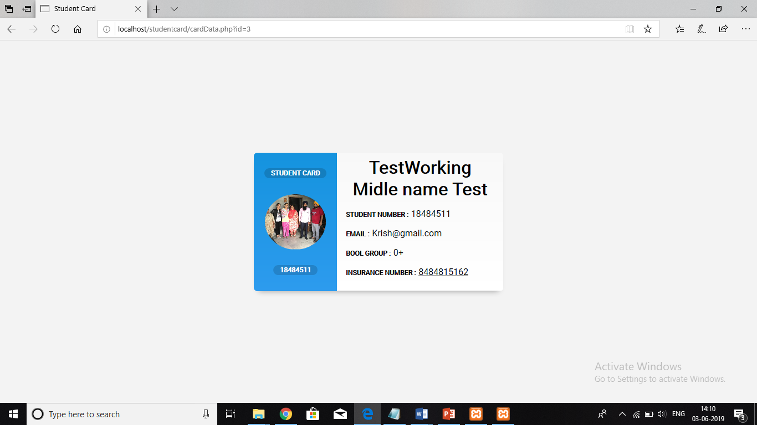

**Test cases Check validations – Passed**

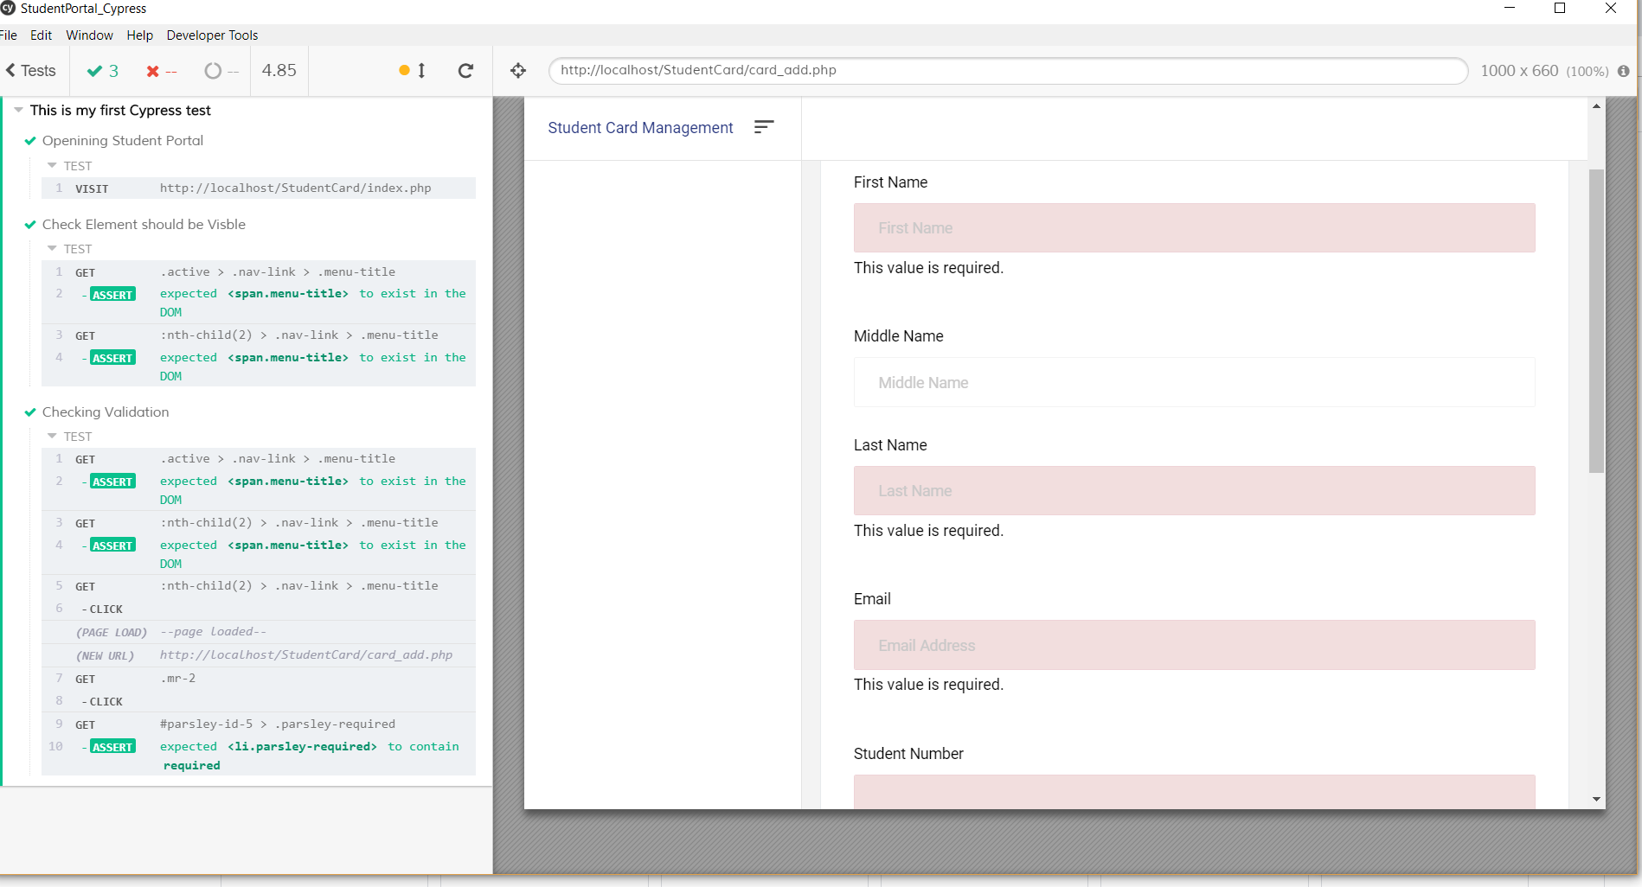

**Updated student info – Passed**

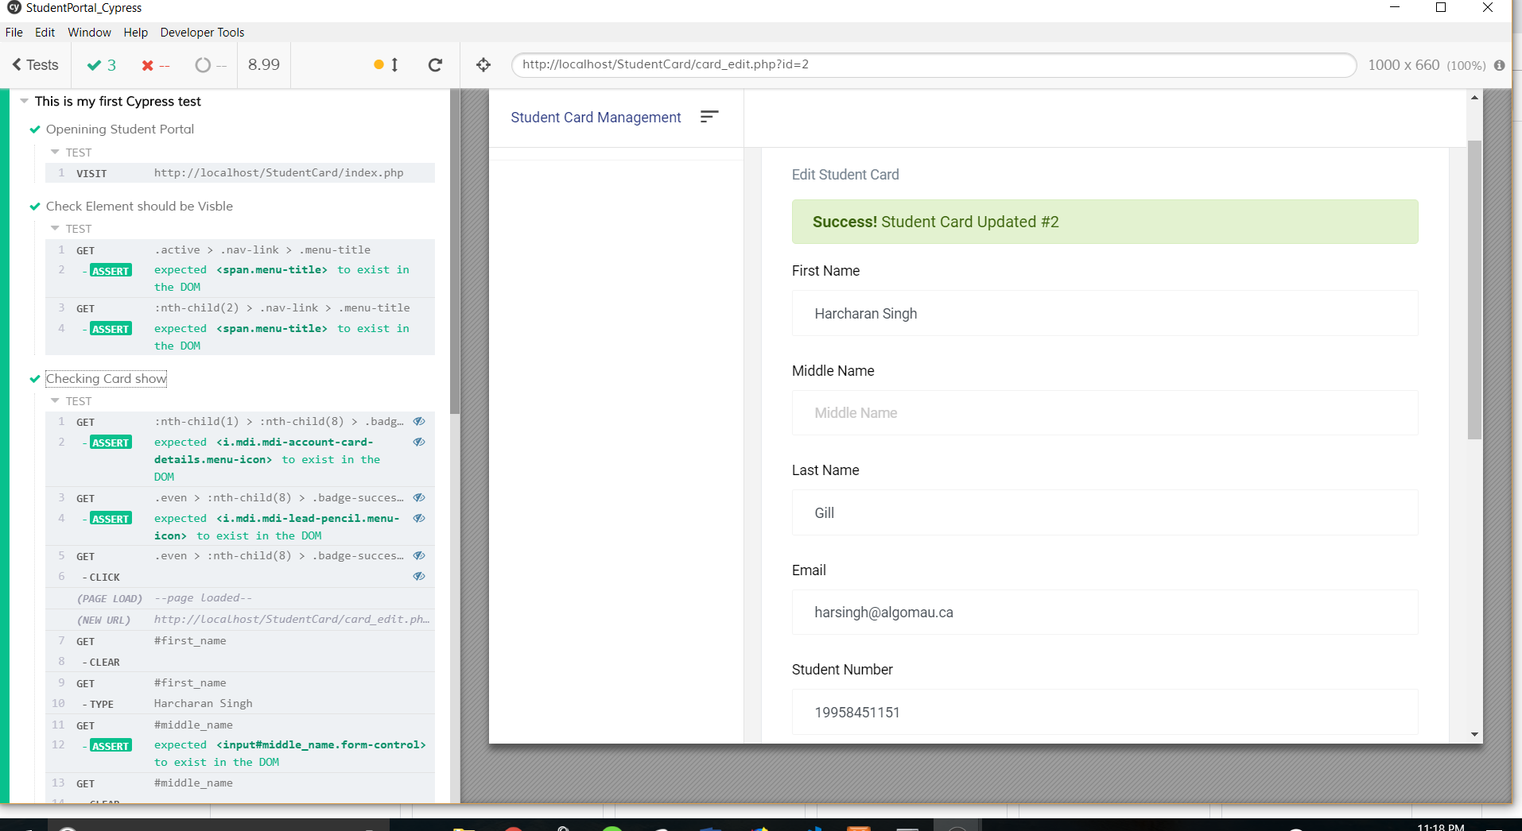

**Registered students**

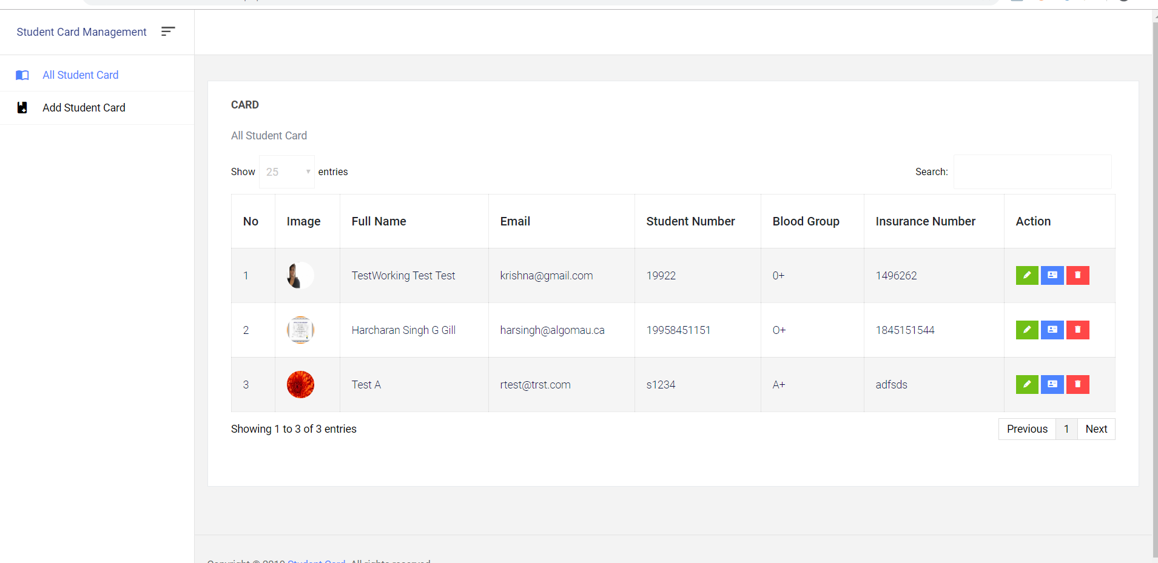

**Display Student Card**

